EUROPEAN COMMISSION
DIRECTORATE-GENERAL
TAXATION AND CUSTOMS UNION
Digital Delivery of Customs and Taxation Policies
Customs Systems

Section II: BUSINESS PROCESS THREADS FOR GUARANTEE MANAGEMENT

Aligned to the business scope of the REGULATION (EU) No 952/2013 OF THE EUROPEAN PARLIAMENT AND OF THE COUNCIL of 9 October 2013 laying down the Union Customs Code (UCC) and its Delegated and Implementing Acts
Date: | 27/07/2021
Status: | Submitted for acceptance (SfA)
Version: | 5.30 EN
Author: | CUSTDEV3
Approved by: | DG TAXUD
Reference number: | DLV-007-5.5-0-1-6
Public: | DG TAXUD external
Confidentiality: | Commission use (CU)

Document control information

Property | Value
Title | Section II: BUSINESS PROCESS THREADS FOR GUARANTEE MANAGEMENT
Subtitle | Aligned to the business scope of the REGULATION (EU) No 952/2013 OF THE EUROPEAN PARLIAMENT AND OF THE COUNCIL of 9 October 2013 laying down the Union Customs Code (UCC) and its Delegated and Implementing Acts
Author | CUSTDEV3
Project owner | Head of Unit of DG TAXUD Unit A2 Customs legislation
Solution provider | DG TAXUD Unit B1 Process and Data, Customer Relationship and Planning
DG TAXUD Project Manager | DG TAXUD Unit B1 Customs Systems
Version | 5.30 EN
Confidentiality | Commission use (CU)
Date | 27/07/2021

Contract information

Property | Value
Framework Contract | TAXUD/2013/CC/124
Specific Contract | SC22

Document history
The document author is authorised to make the following types of changes to the document without requiring that the document be re-approved:
- Editorial, formatting, and spelling;
- Clarification.
To request a change to this document, contact the document author or project owner.
Changes to this document are summarised in the table in reverse chronological order (latest version first).
Version* | Date | Description | Action | Section
5.30 | 27/07/2021 | Implementing QA4 and DG TAXUD review comments.  Submitted for Acceptance (SfA) to Taxation and Customs Union DG. | I/R | As Required
5.20 | 13/07/2021 | Implementing NA external review comments.  Submitted for Review (SfR) to Taxation and Customs Union DG. | I/R | As Required
5.10 | 06/04/2021 | Implementing QA4 and DG TAXUD review comments.  Submitted for Acceptance (SfA) to Taxation and Customs Union DG. | I/R | As Required
5.00 | 10/03/2021 | Implementing QTM007.  Submitted for Review (SfR) to Taxation and Customs Union DG. | I/R | As Required
Action: I=Insert R=Replace

*Previous Document History before v5.00 is not available.

Configuration management: document location
The latest accepted version of this controlled document is stored on: CIRCABC
Table of contents
1. “Pure” NCTS 5
1.1 Introduction 5
1.1.1 Purpose of this Chapter 5
1.1.2 Definitions 5
1.1.3 Guarantee Check & Lock 7
1.1.4 Monitoring the Use of Guarantee 7
1.1.5 Use of Certificates in “Pure” NCTS 8
1.1.6 Remarks 8
1.1.7 Constraints 9
1.2 L4-TRA-02-00-Transit Guarantee Processing Management Master Process 10
1.3 L4-TRA-02-01- Check Guarantee Integrity 11
1.4 L4-TRA-02-03-Register Guarantee Usage 14
1.5 L4-TRA-02-04-Credit Reference Amount 18
1.6 L4-TRA-02-05-Release Guarantee 20
1.7 L4-TRA-02-06-Cancel Guarantee Usage 23
1.8 L4-TRA-02-07-Manage Guarantor 26
1.9 L4-TRA-02-08-Capture Access Codes 28
1.10 L4-TRA-03-00- Transit Guarantee Validation Management Master Process 30
1.11 L4-TRA-03-01-Process Individual Guarantee by Guarantor 31
1.12 L4-TRA-03-02-Process Comprehensive Guarantee 34
1.13 L4-TRA-03-03-Review Amounts of Comprehensive Guarantee 37
1.14 L4-TRA-03-04-Update Comprehensive Guarantee Data 40
1.15 L4-TRA-03-05-Cancel (and Revoke) Comprehensive Guarantee 42
1.16 L4-TRA-03-06-Process individual Guarantee in the form of vouchers 45
1.17 L4-TRA-03-07-Sell NCTS individual Guarantee Vouchers 48
1.18 L4-TRA-03-08-Cancel (and revoke) Individual Guarantee in the form of vouchers 50

List of figures
Figure 1: L4-TRA-02-00-Transit Guarantee Processing Management Master Process 10
Figure 2: L4-TRA-02-01-Check Guarantee Integrity 11
Figure 3: L4-TRA-02-03-Register Guarantee Usage 14
Figure 4: L4-TRA-02-04-Credit Reference Amount 18
Figure 5: L4-TRA-02-05-Release Guarantee 20
Figure 6: L4-TRA-02-06-Cancel Guarantee Usage 23
Figure 7: L4-TRA-02-07-Manage Guarantor 26
Figure 8: L4-TRA-02-08 - Capture Access Codes 28
Figure 9: L4-TRA-03-00 –Transit Guarantee Validation Management Master Process 30
Figure 10: L4-TRA-03-01-Process Individual Guarantee by Guarantor 31
Figure 11: L4-TRA-03-02-Process Comprehensive Guarantee 34
Figure 12: L4-TRA-03-03-Review Amounts of Comprehensive Guarantee 37
Figure 13: L4-TRA-03-04-Update Comprehensive Guarantee Data 40
Figure 14: L4-TRA-03-05-Cancel (And Revoke) Comprehensive Guarantee 42
Figure 15: L4-TRA-03-06-Process Individual Guarantee in the form of Vouchers 45
Figure 16: L4-TRA-03-07-Sell NCTS Individual Guarantee Vouchers 48
Figure 17: L4-TRA-03-08-Cancel (and revoke) Individual Guarantee in the Form of Vouchers 50

“Pure” NCTS

Introduction

Purpose of this Chapter
This chapter deals with the management of guarantee in general, independently of the subsystem where guarantee data is recorded, i.e.:
- the guarantee management subsystem, at the Customs Office of Guarantee, where the data related to individual guarantee by Guarantor, individual guarantee in the form of vouchers, comprehensive guarantee, individual guarantee with multiple usage, guarantee waiver, is recorded;
- the Customs Office of Departure subsystem where the other guarantees are handled.
This chapter also covers the services required by the Customs Office of Departure from the guarantee management subsystem, namely:
- Check guarantee integrity;
- Register guarantee usage;
- Release guarantee;
- Credit reference amount;
- Cancel guarantee usage.

Definitions
The Holder of Transit procedure shall furnish a guarantee in order to ensure payment of the debt which may be incurred in respect of the goods.

GENERAL
Guarantee:
An enforceable legal instrument with which a customs administration can recover duties and taxes which become payable in the event of irregularities during a transit movement.

The guarantee shall be:
(a) either an individual guarantee covering a single common transit operation (Cash deposit, individual guarantee by guarantor, individual guarantee in the form of vouchers);
(b) or, where a simplification is used, a comprehensive guarantee covering several operations (Comprehensive guarantee, individual guarantee with multiple usage, guarantee waiver).

Reference amount:
The amount of the debt which may be incurred in respect of goods the Holder of Transit procedure places under the transit procedure.
Guarantee certificate:
A certificate issued by a Customs Office of Guarantee to a Holder of Transit procedure to enable the latter to start a transit movement.

Guarantee Types
The guarantee types are coded from 0 to 9 and letters A, Β (see Implementing Provisions, annexes 38 and 37-c as well as Transit Convention, annex A2 to Appendix III):
- Code 0: For guarantee waiver (Article 95(2) of the Code);
- Code 1: For comprehensive guarantee (Article 89(5) of the Code);
- Code 2: For individual guarantee in the form of an undertaking by a guarantor (Article 92(1)(b) of the Code);
- Code 3: For individual guarantee in cash or other means of payment recognised by the customs authorities as being equivalent to a cash deposit, made in euro or in the currency of the Member State in which the guarantee is required (Article 92(1)(a) of the Code);
- Code 4: For individual guarantee in the form of vouchers (Article 92(1)(b) of the Code and Article 160);
- Code 5: For guarantee waiver where the amount of import or export duty to be secured does not exceed the statistical value threshold for declarations laid down in accordance with Article 3(4) of Regulation (EC) No 471/2009 of the European Parliament and of the Council (*) (Article 89(9) of the Code);
- Code 8: For guarantee not required for certain public bodies (Article 89(7) of the Code);
- Code 9: Individual guarantee with multiple usage. (Point 3 of Annex 47 IP and Annex 4 of Appendix I of the Convention);
- Code A: For guarantee waiver by agreement (Article 10(2) (a) of the Convention) (EFTA code only);
- Code B: For guarantee furnished for goods dispatched under TIR procedure;
- Code J: Guarantee not required for the journey between customs office of departure and customs office of transit – Article 10(2)(b) of the Convention of 20 May 1987 on a common transit procedure.

All of them will be recognised by NCTS at declaration validation.
The guarantee management subsystem will manage the following guarantee types:
- Code 0: Guarantee waiver;
- Code 1: Comprehensive guarantee;
- Code 2: Individual guarantee (by Guarantor);
- Code 4: Individual guarantee in the form of vouchers;
- Code 9: Individual guarantee with multiple usage.

The Customs Office of Departure subsystem will manage the following guarantee types:
- Code 3: Cash deposit guarantee (by Holder of Transit procedure);
- Code 5: For guarantee waiver where the amount of import or export duty to be secured does not exceed the statistical value threshold for declarations laid down in accordance with Article 3(4) of Regulation (EC) No 471/2009 of the European Parliament and of the Council (*) (Article 89(9) of the Code);
- Code 8: Guarantee not required for certain public bodies;
- Code A: Guarantee waiver by agreement;
- Code J: Guarantee not required for the journey between customs office of departure and customs office of transit.

Guarantee types not a subject of guarantee management process:
- Code B: For guarantee furnished for goods dispatched under TIR procedure;

NCTS INDIVIDUAL GUARANTEE Voucher
An NCTS individual guarantee voucher is the equivalent, in NCTS, of paper individual guarantee vouchers sold, but not used, cannot be used anymore for placing goods under the Transit procedure.

Guarantee Reference Number (GRN)
Each NCTS guarantee will be referenced by a unique Guarantee Reference Number (GRN) which will be used for validation in the guarantee management sub system.

The "Guarantee Reference Number" (GRN) is allocated by the Customs Office of Guarantee to identify each single guarantee.

Access code
A specific guarantee may only be used by the persons who are authorised to do so. The authentication of these persons will be done by means of a guarantee access code.
The guarantee access code can be considered as a secret security code (or kind of password) to secure the use of a specific guarantee. This access code is defined at the level of the guarantee:
- for comprehensive guarantees, individual guarantee with multiple usage, and guarantee waivers, the Holder of Transit procedure has to allocate one or more access codes per guarantee and to communicate this information to people he authorises to use the guarantee;
- for each individual guarantee the Customs Office of Guarantee allocates an access code and communicates this information to the Holder of Transit procedure;
- for NCTS individual guarantee vouchers, the Guarantor allocates an access code per NCTS individual guarantee voucher sold and communicates that information to the Holder of Transit procedure. The latter will be responsible for communicating this information to people that he authorises to use the NCTS individual guarantee voucher he bought.

Guarantee Check & Lock
For the Transit operations, during the departure processing, when requested by the Customs Officer, a first guarantee check can be performed at the time the declaration data is verified (see Section I under Heading 2.14.2 ‘Customs’ Movement State System’). This is formalised by the means of two ‘information to be exchanged’ flows: ‘GUARANTEE CHECK’ (IE200), and ‘GUARANTEE CHECK RESULT’ (IE201).
A guarantee check & lock is performed just before the issuing of the Transit transaction data. When the check is successful, the guarantee usage is automatically registered (implicit lock). When the check is not successful, the result and reason are sent back, and no guarantee lock is performed. This is formalised by two ‘information to be exchanged’ flows: ‘GUARANTEE USE’ (IE203), and ‘GUARANTEE USE RESULT’ (IE205).

Monitoring the Use of Guarantee
In this context, “monitoring” means the way NCTS will track the use of a guarantee, i.e. the data that is recorded at use time.
Basically, there are 3 types of monitoring the use of a guarantee, coded as follows:
- Code 1: MRN, date;
- Code 2: MRN, date, amount;
- Code 3: MRN, date, amount, and update account (decrease at lock-time, increase at release-time).
For each type of guarantee managed by the guarantee management subsystem, the monitoring type should be chosen when the guarantee is created in the NCTS, according to the following table:

 | Monitoring code
 | 1 | 2 | 3
Guarantee waiver (code 0) |  |  | x
Comprehensive guarantee (code 1) |  |  | x
Individual guarantee (by Guarantor) (code 2) | x | x
NCTS individual guarantee vouchers (code 4) | x | x
Individual guarantee with multiple usage (code 9) |  |  | x

Use of Certificates in “Pure” NCTS
Currently a guarantee certificate has 2 goals:
- to prove the existence of a comprehensive guarantee or guarantee waiver to cover Transit movements;
- to declare and authenticate the persons authorised (by the Holder of Transit procedure) to use the related guarantee of the Holder of Transit procedure.
For the first goal, in “pure” NCTS, the existence of a guarantee will be proved by the existence of the GRN in the guarantee management subsystem and not by means of guarantee certificates (which are easy to forge).
For the second goal, in “pure” NCTS the check (at Customs Office of Departure) if the person presenting the declaration is authorised to use the guarantee of the Holder of Transit procedure will be made on the basis of an access code associated to the guarantee.
So, in ‘pure’ NCTS the guarantee certificates are no longer strictly necessary, unless for the Business Continuity Procedure (Annex 72-04 of IA).

Remarks
- NCTS will only provide support for the management of guarantee data related to the guarantee usage to cover NCTS-Transit movements.
- The physical management of the Guarantor’s undertaking (the guarantee paper-documents) is a national matter and out of the scope of NCTS.
- The Transit movements involved in the estimation of the reference amount of a new comprehensive guarantee or guarantee waiver (or the estimation of the amount of a new individual guarantee with multiple usage) are the Transit movements initiated from Offices of Departure in the same country as the one where the guarantee is issued.
- The review of the amounts of point 3 above will be based on the usage of the given guarantee to cover Transit movements initiated from any Offices of Departure in the Transit community.
- The issuing of individual guarantee vouchers (documents) is a Guarantor’s matter and therefore has to be considered as out of the scope of NCTS.
- When a comprehensive guarantee or an individual guarantee with multiple usage is cancelled:
- the concerned guarantee can no longer be used to cover new Transit movements;
- the Guarantor is still liable for all the related Transit movements (covered by this guarantee) that are not yet written-off. It is only when the concerned Transit movements are written-off that the Guarantor will be released from his obligations.
- When an individual guarantee in the form of vouchers has been cancelled:
- the Guarantor may no longer issue individual guarantee vouchers (documents);
- Individual guarantee vouchers sold, but not used, cannot be used anymore for placing goods under the common transit procedure;
- the Guarantor remains engaged until the writing-off of the movements covered with individual guarantee vouchers used before the revocation;
- the Holder of the Transit Procedure and/or the Guarantor are allowed to perform guarantee queries to the Guarantee Management System to check the details of their own guarantees even though no MRN may have been allocated to the transit movement yet.

Constraints
- When a fraud is proved or the non-completion of a Transit movement is established, the Customs Administration of the country in which the goods are deemed to be diverted to chargeable use will attempt to recover (the amount of duties & taxes) from the Holder of Transit procedure. If this recovery-step fails, then the Customs Administration will recover from the Guarantor. This recovery-process will remain a manual process in NCTS. The only support that NCTS can give is to provide the Customs Administration of the country of recovery with the information about the concerned Holder of Transit procedure and Guarantor. This information will be retrieved based on the MRN (see Section I under L4-TRA-01-11-Process Query Movement Information’) and GRN(s) used to cover that movement (see this Section under L4-TRA-02-02-Process Query on Guarantees).
- The decision to refuse or accept the presented guarantee undertaking is based on the experience of the Customs Officer and on the legislation (cannot be computerised).
- All amounts can be expressed either in national currencies or in EURO. In case of international use of a guarantee, the amounts will be expressed in EURO. So, the Holder of Transit procedure is: ‘The sender applies the exchange rate from his national currency to the common European currency, the receiver applies the exchange rate from the common European currency to his national currency’. Therefore, a unique ‘exchange rates table’ is used for the conversion by the sender and the receiver. This table is managed at the Common Domain (see Section IV under Heading 1.9 ‘CS4A - Common Domain manages and maintains ISO/UNECE Codes, Union/Common Transit Codes, and Other Reference Data’).
- The management of differences in exchange rates between the time of registering the guarantee usage and the time of recovery is out of scope of NCTS.

L4-TRA-02-00-Transit Guarantee Processing Management Master Process
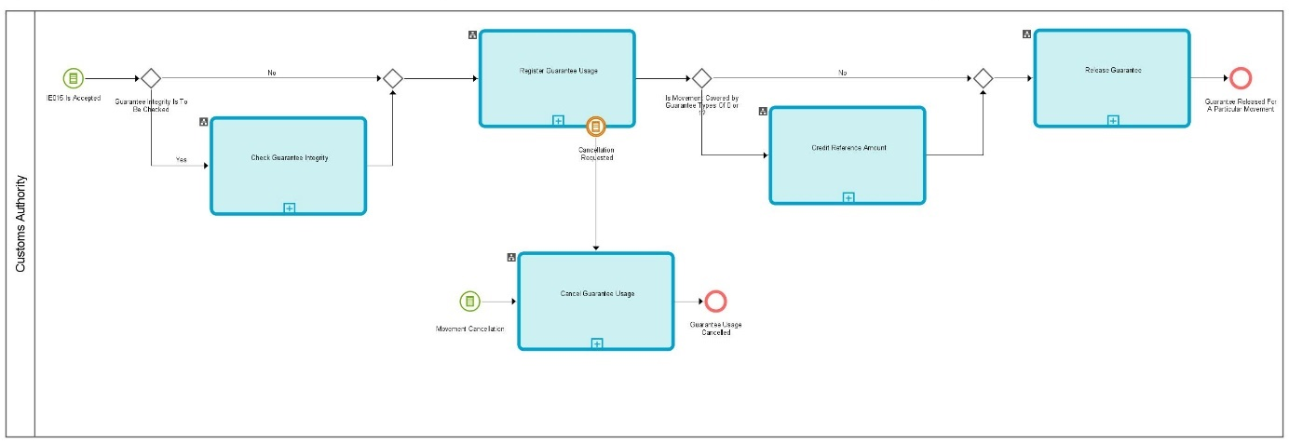

Figure 1: L4-TRA-02-00-Transit Guarantee Processing Management Master Process

L4-TRA-02-01- Check Guarantee Integrity
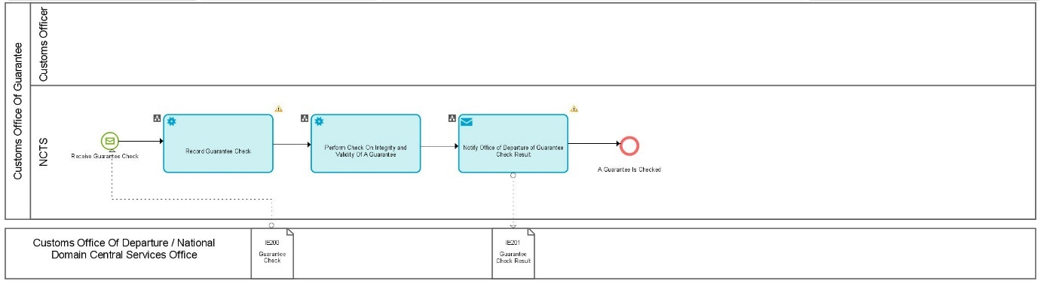
Figure 2: L4-TRA-02-01-Check Guarantee Integrity

Major Event
Receive Guarantee Check
Organisation : National Customs Administration
Location : Customs Office of Departure, or National Domain Central Services
A Party (Customs Office of Departure or National Domain Central Services) asks to check the integrity and the validity of a guarantee which is under the management responsibility of the Customs Office of Guarantee (i.e. in the guarantee management subsystem). This event might be generated by:
- the Customs’ Movements State System (see Section I, under Heading 2.14.2 ‘Customs’ Movements State System’);
the Trader’s Declarations State System (see Section I, under Heading 2.14.2 ‘Trader’s Declarations State System’).
Process
Check guarantee integrity | Process: L4-TRA-02-01
Organisation : National Customs Administration
Location : Customs Office of Guarantee
Constraint :
Guarantee check has to be done against the most recent value of the guarantee data. This implies that the guarantee check has to be done on-line.
Depending on the implementation, this may cause a certain time delay.
Description:
NCTS is receiving (IE200) a request to check the integrity and the validity of a guarantee.
Depending on the type of the referenced guarantee (IE200.GUARANTEE TYPE. Guarantee type), the following cases have to be considered.
- For an NCTS individual guarantee voucher (code 4), following integrity checks will be performed:
- Check if the individual guarantee voucher exists and is still valid;
- Check the validity of the access code against the voucher presented;
- Check if the Holder of Transit procedure of the voucher corresponds to the Holder of Transit procedure of the declaration;
- For an individual guarantee by Guarantor (code 2), following integrity checks will be performed:
- Check if the guarantee exists and has not been used;
- Check the guarantee amount;
- Check the validity of the access code against the guarantee;
- Check if the Holder of Transit procedure of the guarantee corresponds to the Holder of Transit procedure of the declaration;
- Check about the territorial validity.
- For a comprehensive guarantee (code 1) and for guarantee waiver (code 0) and for individual guarantee with multiple usage (code 9), following integrity checks will be performed:
- Check if the guarantee exists and is valid;
- Check the validity of the access code against the guarantee;
- Check if the Holder of Transit procedure of the guarantee corresponds to the Holder of Transit procedure of the declaration;
- Check if the reference/guarantee amount(s) is (are) being exceeded. (In case of monitoring type ‘3’, the amount to be covered may not exceed the balance of the reference amount for guarantee codes ‘0’ and ‘1’);
- Check about the territorial validity.
The results of this guarantee check are returned (IE201) to the requesting party.
Final situation :
The guarantee check is done, and the result is available.
Major Result
A Guarantee is checked
Organisation : National Customs Administration
Location : Customs Office of Departure, or National Domain Central Services
The guarantee check, as requested by a competent party, has been performed.

L4-TRA-02-03-Register Guarantee Usage
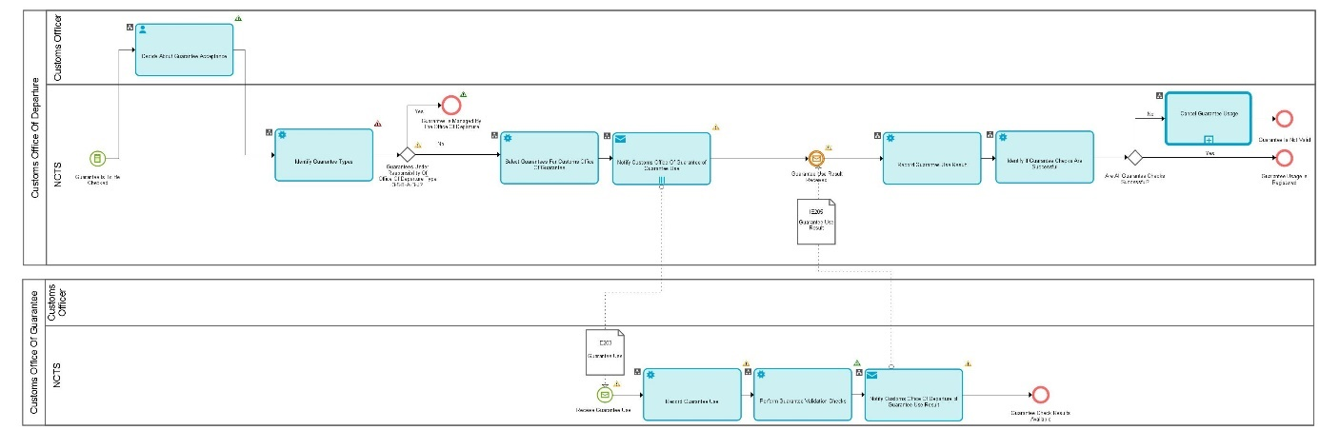
Figure 3: L4-TRA-02-03-Register Guarantee Usage

Major Event
Guarantee is to be checked
Organisation : National Customs Administration
Location : Customs Office of Departure
The Customs Office of Departure asks for the check of guarantees. This event is generated by the Core Business Process Thread: “(L4-TRA-01-01-Process Departure - Acceptance and Controls (part B) FTSS Section II).
Processes
Register Guarantee Usage | Process: L4-TRA-02-03
Check and register usage of guarantees (codes 3, 5, 8, A, B and J)
Organisation : National Customs Administration
Location : Customs Office of Departure
Constraint :
Description:
When considering the guarantees to be checked, the Customs Office of Departure establishes a selection between two groups of guarantee types (see under Heading 1.1.2.2 : Guarantee Types):
- Guarantees under the responsibility of the Customs Office of Departure: code 3, code 5, code 8, code A, code B and code J and
- Guarantees under the responsibility of the Customs Office of Guarantee: code 0, code 1, code 2, code 4, and code 9.
The Customs Officer at the Customs Office of Departure first handles the guarantee of types coded as 3, 5, 8, J, A and B.
- If one of the guarantee(s) checks is not successful, none of the guarantee usage(s) is finally recorded;
- If the checks of all the guarantees are successful:
- In case of individual guarantee in cash or other means of payment recognised by the customs authorities as being equivalent to a cash deposit, made in euro or in the currency of the Member State in which the guarantee is required (Article 92(1)(a) of the Code (code 3)) the deposit (requested amount), provided by the Holder of Transit procedure to the Customs Office of Departure, is collected and a receipt is delivered to the Holder of Transit procedure.
- The guarantee usage for these types of guarantee are recorded in NCTS.
Final situation :
Guarantee usage for guarantee of types coded as 3, 5, 8, A, B, J is refused or recorded in NCTS.

Register Guarantee Usage | Process: L4-TRA-02-03
Select guarantees for Customs Office of Guarantee
Organisation : National Customs Administration
Location : Customs Office of Departure
Constraint : Maximum two Customs Administrations involved i.e. administration of the country of Departure and only one other national administration.
Description :
After a successful handling of the guarantee of types coded as 3, 5, 8, A, B, J, NCTS dispatches the guarantee(s) of types coded as 0,1,2,4,9 which are of the responsibility of the Customs Office of Guarantee to the corresponding Offices of Guarantee. The information about these guarantees is prepared and communicated (IE203) to each of the competent Offices of Guarantee, for checking and registering.
Final situation :
The guarantees of types coded as 0,1,2,4,9 which are under the responsibility of the Office(s) of Guarantee are selected.

Register Guarantee Usage | Process: L4-TRA-02-03
Check and register usage of guarantees (Codes 0, 1, 2, 4 and 9)
Organisation : National Customs Administration
Location : Offices of Guarantee
Constraint: Maximum two Customs Administration involved i.e. administration of the country of Departure and only one other national administration (in circa 5 % of the cases). In the latter case, the response must be sent within 5’.
Description:
The Offices of Guarantee are receiving (IE203) the information about the guarantees which are to be checked out and registered. If different types of guarantee are covering a same Transit movement the fixed amount guarantees (individual guarantee by guarantor, individual guarantee vouchers) are checked before all other (variable amount) types of guarantee.
If the checks of all the received guarantees are successful, their usage is recorded.
But if one of the guarantee checks failed, none of the guarantee usage is finally recorded.
The results of the guarantees check are forwarded (IE205) to the Customs Office of Departure.
Final situation :
When checks successful, the usage of the guarantee types 0,1,2,4,9 to cover a Transit movement is recorded. Guarantee checks results are forwarded to the Customs Office of Departure.

Register Guarantee Usage | Process: L4-TRA-02-03
Analyse results of guarantees check
Organisation : National Customs Administration
Location : Customs Office of Departure
Constraint :
Description :
The Customs Office of Departure is receiving (IE205) the results of the guarantee checking from each of the Office(s) of Guarantee responsible for the guarantees of types coded as 0,1,2,4,9.
If the guarantee check is not successful, the cancellation of the usage of already registered guarantees is started.
In any case, the results of the guarantee checks are made available and are ready to be evaluated (see L4-TRA-01-02-Process Departure - Release).
Final situation :
The results of checks of the guarantee of types coded as 0,1,2,4,9 are made available.
Major Results
Guarantee is managed by the Office Of Departure
Organisation : National Customs Administration
Location : Customs Office of Departure
The usage of a guarantee of types coded as 3, 5, 8, A, B, J to cover a Transit movement is registered

Guarantee usage registered
Organisation : National Customs Administration
Location : Offices of Guarantee
The usage of a guarantee of types coded as 0,1,2,4,9 to cover a Transit movement is registered

Guarantee check results available
Organisation : National Customs Administration
Location : Customs Office of Departure
The guarantee checks from the competent Office(s) of Guarantee are available at the Customs Office of Departure

Guarantee is not valid
Organisation : National Customs Administration
Location : Customs Office of Departure
The cancellation of guarantee usage is started

L4-TRA-02-04-Credit Reference Amount
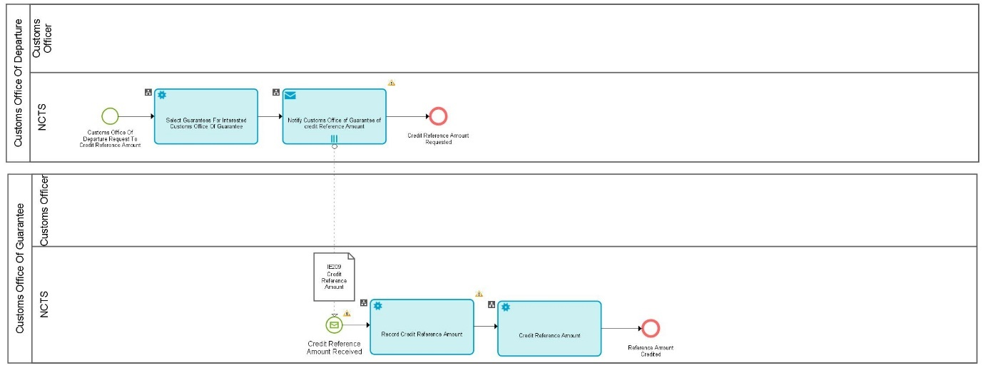
Figure 4: L4-TRA-02-04-Credit Reference Amount
Major Event
Customs Office of Departure requests to credit reference amount
Organisation : National Customs Administration
Location : Customs Office of Departure
The Customs Office of Departure asks to credit the reference amount. This event is generated by the Core Business Process Thread: “(L4-TRA-01-03-PROCESS ARRIVAL (part B) FTSS Section II).
Processes
Credit Reference Amount | Process: L4-TRA-02-04
Credit reference amount
Organisation : National Customs Administration
Location : Customs Office of Guarantee
Constraint: This process concerns only guarantee types ‘0’ and ‘1’.
Description:
The locked reference amount for the particular Transit movement is credited and the reserved amount is placed back to the balance of the guarantee. This is recorded in the guarantee management subsystem.
Final situation :
The credit of the reference amount is recorded in the guarantee management subsystem.

Credit Reference Amount | Process: L4-TRA-02-04
Select guarantees for interested Customs Office of Guarantee
Organisation : National Customs Administration
Location : Customs Office of Departure
Constraint: This process concerns only guarantee types ‘0’ and ‘1’. - Maximum Two Customs Administrations involved i.e. administration of the country of Departure and only one other national administration.
Description:
Upon receipt of message IE006 (Arrival Advice) for movements covered by a guarantee of types ‘1’ or ‘0’, NCTS selects the different Offices of Guarantee concerned and asks them to credit the reference amount (IE209).
Final situation :
The credit of the reference amount has been asked.
Major Results
Reference Amount Credited (code: 0, 1)
Organisation : National Customs Administration
Location : Customs Offices of Guarantee
The credit of the reference amount for guarantee types ‘0’ and ‘1’ is recorded.

L4-TRA-02-05-Release Guarantee
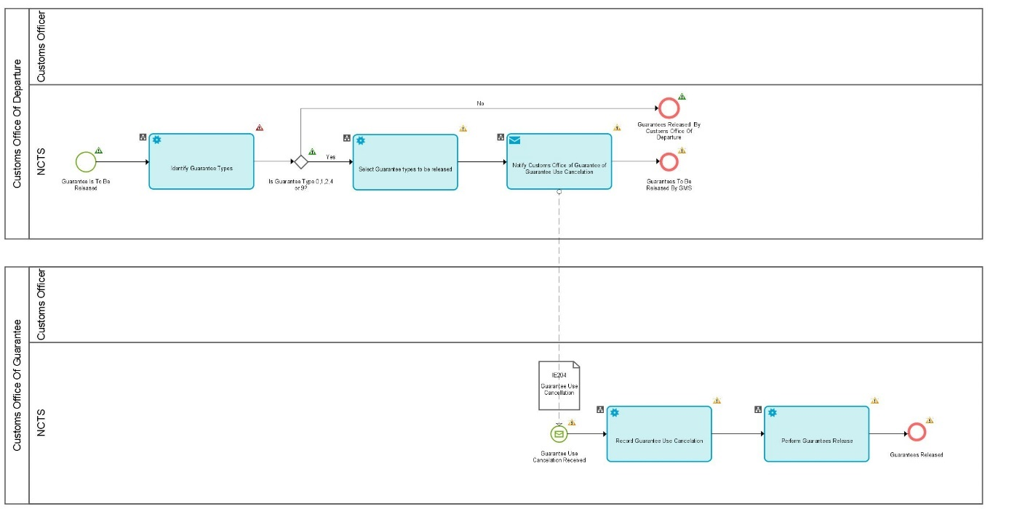

Figure 5: L4-TRA-02-05-Release Guarantee

Major Event
Guarantee is to be released
Organisation : National Customs Administration
Location : Customs Office of Departure
The Customs Office of Departure asks for the release of guarantees. This event is generated by the Core Business Process Thread: ‘L4-TRA-01-03-PROCESS ARRIVAL (Part A and B)’, and whenever a movement is written off (e.g. after recovery).
Processes
Release Guarantee | Process: L4-TRA-02-05
Evaluate type of guarantee and release guarantee usage
Organisation : National Customs Administration
Location : Customs Office of Departure
Constraint :
Description:
When the guarantees have to be released, i.e. when the movement is written off or recovery has been completed, the Customs Office of Departure establishes a selection between two groups of guarantee types (see under Heading 1.1.2.2 : Guarantee Types):
- Guarantees under the responsibility of the Customs Office of Departure: code 3, code 5, code 8, code A, and code J and
- Guarantees under the responsibility of the Customs Office of Guarantee: code 0, code 1, code 2, code 4, and code 9.
The Customs Officer at the Customs Office of Departure handles the guarantee of types coded as 3, 5, 8, A and J.
The cash deposit guarantee (code 3) is returned to the Holder of Transit procedure.
The release of the guarantee is recorded in the Customs Office of Departure subsystem.
The other guarantees (codes 0, 1, 2, 4, 9) are selected for the different Office(s) of Guarantee which are responsible for the release of their usage.
Final situation :
The guarantee of types coded as 3, 5, 8, A, J are released.

Release Guarantee | Process: L4-TRA-02-05
Select guarantees for interested Customs Office of Guarantee
Organisation : National Customs Administration
Location : Customs Office of Departure
Constraint: Maximum two Customs Administrations involved i.e. administration of the country of Departure and only one other national administration.
Description:
After the release of the usage of guarantees (codes 3, 5, 8, A, J) NCTS selects the guarantee(s) of types coded as 0, 1, 2, 4 and 9 which are of the responsibility of the Customs Office of Guarantee. The information about these guarantees is prepared and sent (IE204) to each of the competent Offices of Guarantee, for releasing the guarantee usage.
Final situation :
The guarantees under the responsibility of the Office(s) of Guarantee are selected.

Release Guarantee | Process: L4-TRA-02-05
Release guarantees usage
Organisation : National Customs Administration
Location : Customs Office of Guarantee
Constraint :
Description :
The release of the guarantee is recorded in the guarantee management subsystem. This implies the credit of the amount insofar as it has not been previously done.
Final situation :
The release of the comprehensive guarantee, the individual guarantee with multiple usage, the guarantee waiver, the individual guarantee by Guarantor, or an individual guarantee voucher for the movement is recorded in the guarantee management subsystem. For guarantee code 9, the amount is credited, for guarantee code 0 and 1, "the reference amount" is credited, insofar as it has not been previously done (i.e. for guarantee types 0 and 1).

Major Results
Guarantee usage released by Customs Office of Departure
Organisation : National Customs Administration
Location : Customs Office of Departure
The release of the guarantees of code 3, 5, 8, A, J to cover a given Transit movement is recorded. The amount of the cash deposit guarantee (code 3) is returned to the Holder of Transit procedure.

Guarantee usage to be released by GMS
Organisation : National Customs Administration
Location : Offices of Guarantee
The release of the guarantees of types coded as 0, 1, 2, 4 and 9 to cover a given Transit movement is recorded. The Guarantor is no longer liable for the guarantee (guarantee codes 2 and 4) / or guarantee amount (guarantee code 1) used to cover the Transit movement that has been written-off. For guarantee code 9, this implies the credit of the amount, for guarantee waiver and comprehensive guarantee, the credit of "the reference amount", insofar as it has not been previously done (i.e. for guarantee types 0 and 1).

L4-TRA-02-06-Cancel Guarantee Usage
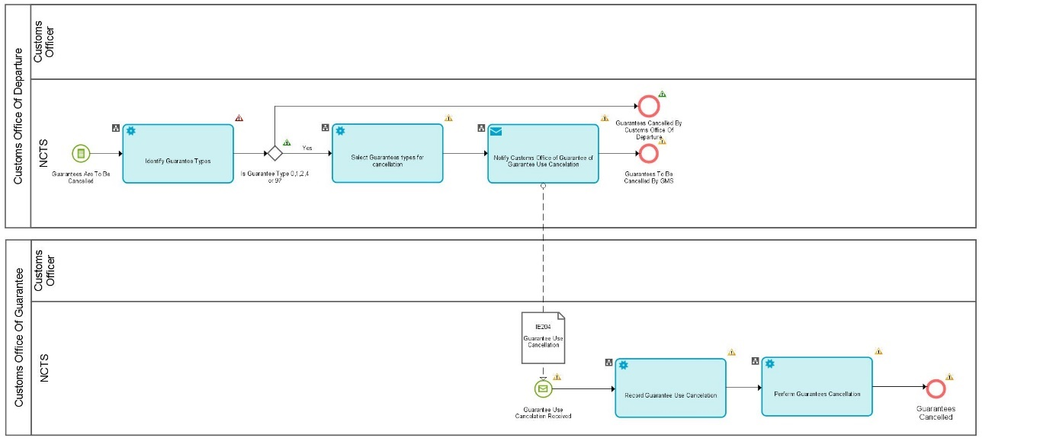
Figure 6: L4-TRA-02-06-Cancel Guarantee Usage

Major Event
Guarantees are to be cancelled
Organisation : National Customs Administration
Location : Customs Office of Departure
This event is generated by the Core Business Process Thread ‘L4-TRA-01-01 Process Departure - Acceptance and Controls’; ‘L4-TRA-01-10-Process Invalidation/Cancellation’ or by Process Threads ‘L4-TRA-02-03-Register Guarantee Usage’.
Processes
Cancel Guarantee Usage | Process: L4-TRA-02-06
Evaluate type of guarantee and cancel guarantee usage
Organisation : National Customs Administration
Location : Customs Office of Departure
Constraint :
Description:
When the guarantee usage(s) has to be cancelled, the Customs Office of Departure establishes a selection between two groups of guarantee types (see under Heading 1.1.2.2 : Guarantee Types):
- Guarantees under the responsibility of the Customs Office of Departure: code 3, code 5, code 8, code A, code J and
- Guarantees under the responsibility of the Customs Office of Guarantee: code 1, code 0, code 2, code 4, and code 9.
The Customs Officer at the Customs Office of Departure handles the guarantee of types coded as 3, 5, 8, A and J.
The previously recorded guarantee usage(s) (in L4-TRA-02-03 Register Guarantee Usage- Check and register usage of guarantees) is (are) removed. This means that the reference to the Transit operation is cleared and/or other pieces of information are cleared.
Final situation :
The usage of the guarantee(s) of types coded as 3, 5, 8, A, and J is cancelled.

Cancel Guarantee Usage | Process: L4-TRA-02-06
Select guarantees for Customs Office of Guarantee
Organisation : National Customs Administration
Location : Customs Office of Departure
Constraint : Maximum two Customs Administration involved i.e. Administration of the country of Departure and only one other national administration
Description:
NCTS selects the guarantee(s) of types coded as 0, 1, 2, 4, 9 that have to be cancelled and asks (IE204) the corresponding Office(s) of Guarantee for their cancellation.
Final situation :
The guarantees under the responsibility of the Office(s) of Guarantee are selected.

Cancel guarantee usage | Process: L4-TRA-02-06
Cancel guarantee usage
Organisation : National Customs Administration
Location : Offices of Guarantee
Constraint :
Description:
The Offices of Guarantee are receiving (IE204) the information about the guarantees for which the usage has to be cancelled.
The previously registered guarantee usage(s) (in Process Threads “L4-TRA-02-03-Register Guarantee Usage”) is (are) removed from the guarantee management subsystem. This means that the reference to the Transit operation is cleared referring for the guarantee of types coded as 0, 1, 2, 4 and 9. Other pieces of information are cleared and/or reset according to the monitoring type of each guarantee. In addition, and especially for individual guarantee by Guarantor and individual guarantee vouchers, this means that they are again “free” to be used.
Final situation :
The usage of the guarantee(s) of types coded as 0, 1, 2, 4, 9 to cover a Transit movement is cancelled.
Major Results
Guarantees cancelled By Customs Office Of Departure
Organisation : National Customs Administration
Location : Customs Office of Departure
The usage(s) of the guarantee(s) of types coded as 3, 5, 8, A, J is (are) cancelled.

Guarantees to be cancelled By GMS
Organisation : National Customs Administration
Location : Customs Office of Guarantee
The usage(s) of the guarantee(s) of types coded as 0, 1, 2, 4, 9 is (are) cancelled from the guarantee management subsystem.

L4-TRA-02-07-Manage Guarantor
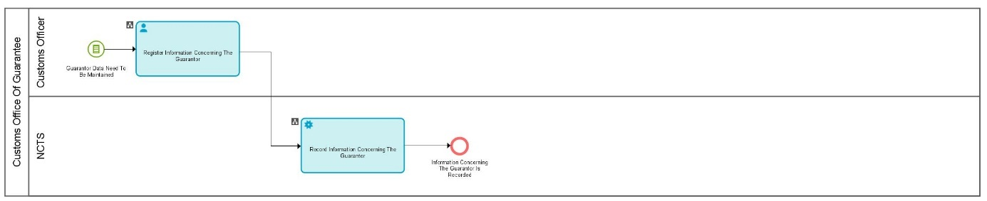

Figure 7: L4-TRA-02-07-Manage Guarantor

Major Event
Guarantor data need to be maintained
Organisation : Guarantor or National Customs Administration
Location : Customs Office of Guarantee
Guarantor data needs maintenance to take into account any updates in known Guarantor data or to create a new Guarantor in the context of a new comprehensive guarantee or a new individual guarantee in the form of vouchers.
Process
Manage Guarantor | Process: L4-TRA-02-07
Maintain Guarantor information
Organisation : National Customs Administration
Location : Customs Office of Guarantee
Constraint :
Description:
General maintenance function. This concerns following Guarantor’s data:
- company name;
- address, contact person, fax number, phone number, telex number, e-mail address;
- contact person in other countries.
Final situation :
Information concerning the Guarantor is registered in NCTS.
Major Result
Information concerning the Guarantor is recorded
Organisation : National Customs Administration
Location : Customs Office of Guarantee
The information concerning the Guarantor is recorded.

L4-TRA-02-08-Capture Access Codes
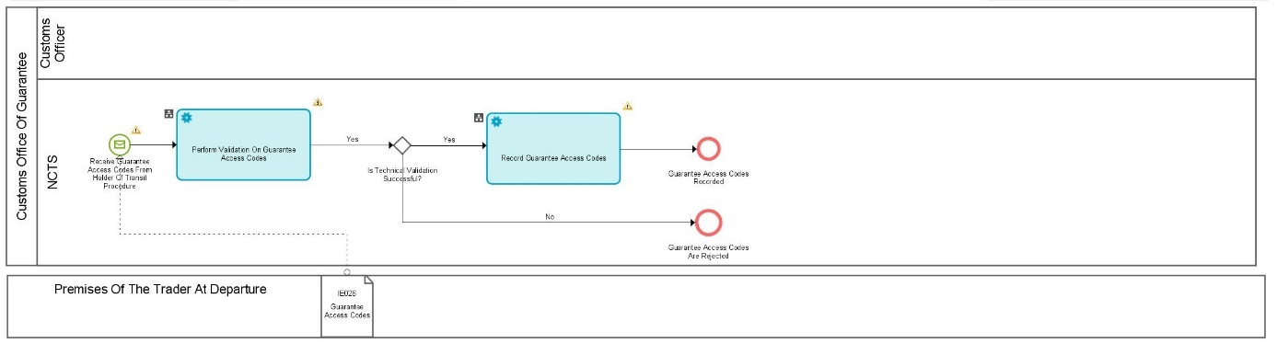
Figure 8: L4-TRA-02-08 - Capture Access Codes
Major Event
Receive Guarantee Access Codes from Holder of Transit Procedure
Organisation : Trader
Location : Premises of the Trader in his country, or Customs Office of Guarantee
The Holder of Transit procedure needs to assign or change the guarantee access codes related to a comprehensive guarantee (code ‘1’), to a guarantee waiver (code ‘0’).
Process
Capture Access Codes | Process: L4-TRA-02-08
Perform Validation On Guarantee Access Codes
Organisation : National Customs Administration
Location : Customs Office of Guarantee
Constraint :
Description:
The Holder of Transit procedure assigns (re-assigns) one or more guarantee access codes to one of his guarantees. He communicates (IE026) the information to the Customs Office of Guarantee.
The guarantee access codes are validated by the GMS. If valid, they are recorded.
Final situation :
The guarantee access codes are recorded in NCTS.
Major Result
Guarantee access codes recorded
Organisation : National Customs Administration
Location : Customs Office of Guarantee
The guarantee access codes are recorded in NCTS.

Guarantee access codes are rejected
Organisation : National Customs Administration
Location : Customs Office of Guarantee
The guarantee access codes are rejected by GMS.

L4-TRA-03-00- Transit Guarantee Validation Management Master Process
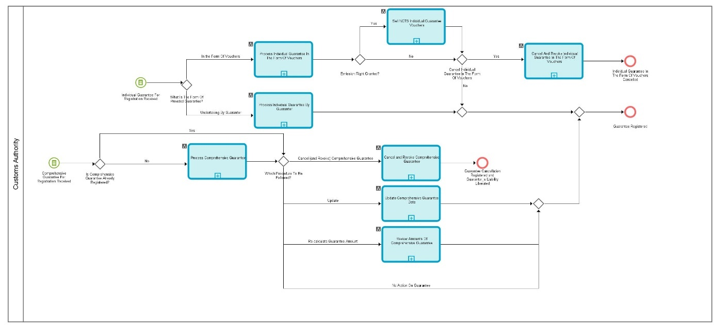

Figure 9: L4-TRA-03-00 –Transit Guarantee Validation Management Master Process

L4-TRA-03-01-Process Individual Guarantee by Guarantor

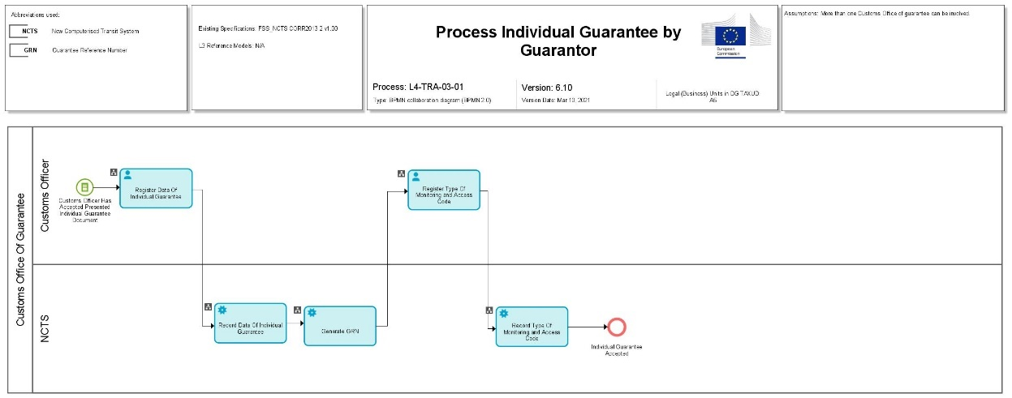

Figure 10: L4-TRA-03-01-Process Individual Guarantee by Guarantor

Major Event
Holder of Transit Procedure presents a document ‘Individual guarantee’
Organisation : Trader
Location : Customs Office of Guarantee
A Holder of Transit procedure presents the document ‘Individual Guarantee’ (see (Article 92(1)(b) of the UCC), of which part I has been filled in by the Guarantor on the basis of data furnished by the Holder of Transit procedure to cover a single Transit movement.

Processes
Process Individual Guarantee by Guarantor | Process: L4-TRA-03-01
Organisation : National Customs Administration
Location : Customs Office of Guarantee
Constraint :
Description:
If the Customs Officer at the Customs Office of Guarantee refuses the presented guarantee, he notifies the Holder of Transit procedure about the rejection.
If the Customs Officer at the Customs Office of Guarantee accepts the presented guarantee (the Guarantor’s undertaking), he completes Part II of the document, allocates an acceptance number, and validates it (stamp and signature).
The data of the accepted guarantee is recorded in the guarantee management subsystem. NCTS builds the GRN based on the acceptance number (see under Heading 1.1.2.4 ’Guarantee Reference Number (GRN)’). The Customs Officer assigns the type of monitoring (normally type 1) and the access code of the guarantee. Relevant paper documents are filled.
Final situation :
The undertaking of the Guarantor is accepted or refused.
The individual guarantee data is recorded in NCTS.

Remark: The process thread L4-TRA-02-07-Manage Guarantor is used to handle any information about the Guarantor, and the process thread CS2A - MANAGE TRADER REGISTRATION is used to handle any information about the Holder of Transit procedure.
Major Results
Individual guarantee refused
Organisation : Trader
Location : Customs Office of Guarantee
The guarantee document (i.e. the undertaking) is refused by the Customs Officer at the Customs Office of Guarantee.

Individual guarantee accepted
Organisation: Trader
Location : Customs Office of Guarantee
The guarantee document (i.e. the undertaking) is accepted by the Customs Officer at the Customs Office of Guarantee.
Minor Result
Individual guarantee document filed
Organisation : National Customs Administration
Location : Customs Office of Guarantee
The document “Individual guarantee” is filed at the Customs Office of Guarantee.

L4-TRA-03-02-Process Comprehensive Guarantee
*This process includes guarantee waiver. The term ‘comprehensive guarantee’ covers the three situations, but the potential differences will be highlighted where necessary in the text of the processes. Comprehensive guarantee includes guarantee waiver in meaning of reduction of the reference amount to 0%.
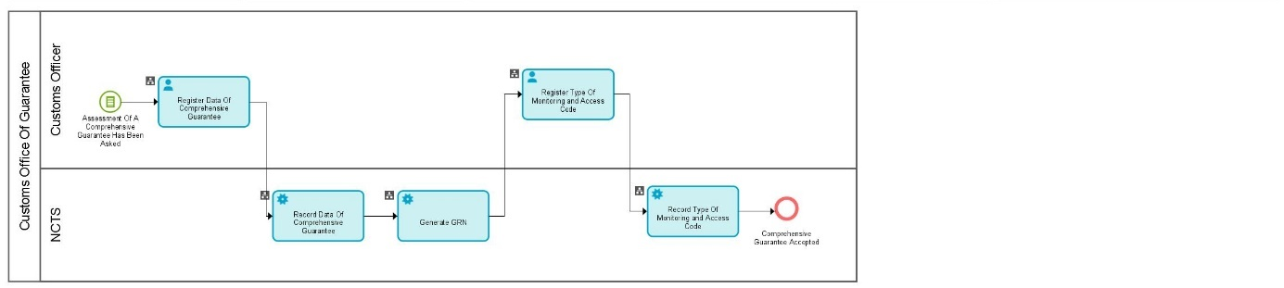

Figure 11: L4-TRA-03-02-Process Comprehensive Guarantee
This process thread manages the guarantees types coded 0 and 1

Major Event
The Holder of Transit procedure asks for assessment of a comprehensive guarantee
Organisation : Trader
Location : Office of Guarantee
A Holder of Transit procedure already authorised to use a comprehensive guarantee (see UCC Article 89(5)) asks for the assessment of the guarantee and the related reference amount.
Processes
Process Comprehensive Guarantee | Process: L4-TRA-03-02
Calculate reference/guarantee amounts and process comprehensive guarantee document
Organisation : National Customs Administration
Location : Customs Office of Guarantee
Constraint : It will not be possible to implement this at the start of NCTS because of the absence of usage history.
Description :
The reference amount of the comprehensive guarantee is calculated by the Customs Officer at the Customs Office of Guarantee, supported by NCTS.
The calculation of the reference amount for a new comprehensive guarantee will only be supported by NCTS on the basis of data about previous movements of this Holder of Transit procedure registered in NCTS e.g. number of Transit movements for a given period of time, related amount (of the duties & taxes) involved.
After having calculated the reference amount, the Customs Office of Guarantee establishes the amount to be covered by the comprehensive guarantee, which is a percentage of the reference amount, i.e. 100 %, 50 %, 30 %, 0 %, the latter being the ‘guarantee waiver’.
If the Customs Officer at the Customs Office of Guarantee refuses the presented guarantee, he notifies the Holder of Transit procedure about the rejection.
If the Customs Officer at the Customs Office of Guarantee accepts the presented guarantee (the Guarantor’s undertaking), he completes Part II of the document, allocates an acceptance number, and validates it (stamp and signature).
Final situation:
The reference and or the guarantee amount of the comprehensive guarantee is (are) determined, and the undertaking of the Guarantor is accepted or refused.

Process Comprehensive Guarantee | Process: L4-TRA-03-02
Register comprehensive guarantee
Organisation : National Customs Administration
Location : Customs Office of Guarantee
Constraint :
Description:
The data of the accepted guarantee is recorded in the guarantee management subsystem. NCTS builds the GRN based on the acceptance number (see under Heading 1.1.2.4 ’Guarantee Reference Number (GRN)’). The Customs Officer and the Holder of Transit procedure decide about the type of monitoring and about the first access code of the guarantee. That access code is the initial (default) access code for the guarantee. It should never be used by the Holder of Transit procedure except for changing it and adding other access codes using the process thread. Relevant paper documents are filled.
Final situation :
The comprehensive guarantee data is recorded in NCTS.

Remark: The process thread L4-TRA-02-07-Manage Guarantor is used to handle any information about the Guarantor, and the process thread CS2A - MANAGE TRADER REGISTRATION is used to handle any information about the Holder of Transit procedure.
Major Results
Comprehensive guarantee refused
Organisation : Trader
Location : Customs Office of Guarantee
The comprehensive guarantee document (i.e. the undertaking) is refused by the Customs Officer at the Customs Office of Guarantee.

Comprehensive guarantee accepted
Organisation: Trader
Location : Customs Office of Guarantee
The comprehensive guarantee document (i.e. the undertaking) is accepted by the Customs Officer at the Customs Office of Guarantee.
Minor Result
Comprehensive guarantee document filed
Organisation : National Customs Administration
Location : Customs Office of Guarantee
The document “Comprehensive guarantee” is filed at the Customs Office of Guarantee.

L4-TRA-03-03-Review Amounts of Comprehensive Guarantee
*This process includes guarantee waiver. The term ‘comprehensive guarantee’ covers the three situations, but the potential differences will be highlighted where considered necessary in the text of the processes.
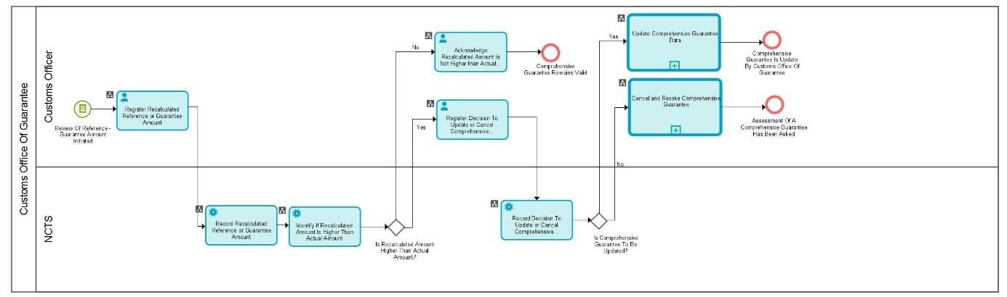

Figure 12: L4-TRA-03-03-Review Amounts of Comprehensive Guarantee
This process thread manages the guarantees types coded 0 and 1
.

Major Event
A party asks to review reference/guarantee amount(s) of a comprehensive guarantee
Organisation : National Customs Administration
Location : Customs Office of Guarantee
This event may be initiated by a Customs Officer at the Customs Office of Guarantee, on request or periodically.

Processes
Review Amounts of Comprehensive Guarantee | Process: L4-TRA-03-03
Re-calculate reference/guarantee amount(s) for the comprehensive guarantee
Organisation : National Customs Administration
Location : Customs Office of Guarantee
Constraint :
Description:
The new reference and guarantee amount(s) needed for the comprehensive guarantee is (are) calculated by the Customs Officer at the Customs Office of Guarantee.
The re-calculation of these amounts will be supported by NCTS, on the basis of data registered by the Customs Administration about previous movements, e.g. number of Transit movements for a given period of time and related amount (of duties & taxes) involved.

Final situation :
The new reference/ guarantee amount(s) of the comprehensive guarantee is (are) determined.

Review Amounts of Comprehensive Guarantee | Process: L4-TRA-03-03
Evaluate new reference/guarantee amount(s) for the comprehensive guarantee
Organisation : National Customs Administration
Location : Customs Office of Guarantee
Constraint :
Description :
The new reference/guarantee amount(s) for the comprehensive guarantee is (are) compared with the existing (original) ones:
- If new amount(s) > existing amount(s): the Customs Officer at the Customs Office of Guarantee is notified that the reviewed amount(s) is (are) higher than the actual amount(s) for the given comprehensive guarantee, i.e. the comprehensive guarantee is no longer sufficient. The comprehensive guarantee should be amended, after an additional or new undertaking from the Guarantor:
- by updating the reference/guarantee amount(s) of the comprehensive guarantee (see process thread L4-TRA-02-04-Update Comprehensive Guarantee Data);
- by replacing the existing comprehensive guarantee by a new one, i.e. cancelling the existing comprehensive guarantee (see process thread L4-TRA-03-05-Cancel (and Revoke) Comprehensive Guarantee) and registering the new comprehensive guarantee (see process thread L4-TRA-03-02-Process Comprehensive Guarantee).
- If new amount(s) ≤ existing amount(s): the comprehensive guarantee remains valid

Final situation :
The amount(s) for the comprehensive guarantee is (are) reviewed.
Major Results
Comprehensive guarantee still valid
Organisation : National Customs Administration
Location : Customs Office of Guarantee
The existing comprehensive guarantee remains valid.

Customs Officer notified about higher reviewed amount(s) for the comprehensive guarantee
Organisation : National Customs Administration
Location : Customs Office of Guarantee
The Customs Officer at the Customs Office of Guarantee is notified that the reviewed amount(s) is (are) higher than the actual amount(s) for the given comprehensive guarantee.

L4-TRA-03-04-Update Comprehensive Guarantee Data
*This process includes guarantee waiver. The term ‘comprehensive guarantee’ covers the three situations, but the potential differences will be highlighted where considered necessary in the text of the processes.

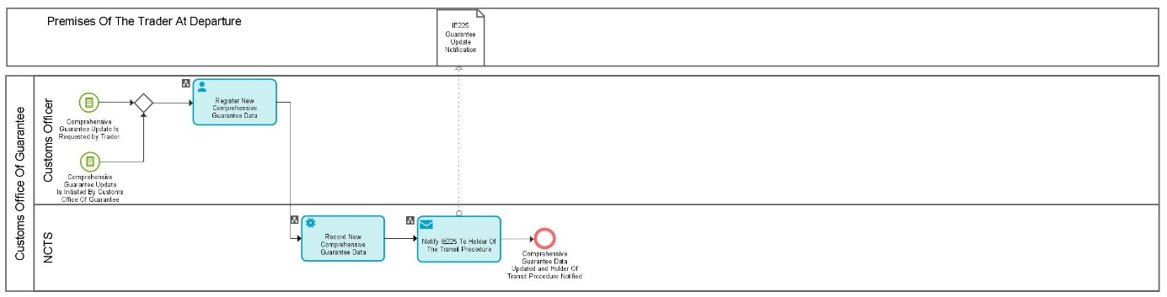

Figure 13: L4-TRA-03-04-Update Comprehensive Guarantee Data
This process thread manages the guarantees types coded 0 and 1

Major Event
Customs Office of Guarantee or a Trader wants to update comprehensive guarantee data
Organisation : Trader, National Customs Administration
Location : Customs Office of Guarantee
The Customs Officer of the Customs Office of Guarantee, or a Trader want to update guarantee data of a comprehensive guarantee.
Process
Update Comprehensive Guarantee Data | Process: L4-TRA-03-04
Capture and register new comprehensive guarantee data
Organisation : National Customs Administration
Location : Customs Office of Guarantee
Constraint :
Description:
An image of the guarantee data before the update is kept as history guarantee data. The identification of the user is recorded with the updated data.
The following data may be updated:
- reference and guarantee amount(s) (a check against the reviewed amount(s) will be executed);
- for comprehensive guarantee (code 1): percentage of the guarantee coverage;
- for comprehensive guarantee (code 1): restricted use (suspended goods);
- territorial validity;
- status (valid/invalid);
The Customs Officer of the Customs Office of Guarantee registers the guarantee data to be updated in NCTS.
The updated guarantee data is communicated (IE225) to the Holder of Transit procedure.
Final situation :
The comprehensive guarantee data are updated in NCTS
Major Results
Comprehensive Guarantee data updated
Organisation : National Customs Administration
Location : Customs Office of Guarantee
The guarantee data of a comprehensive guarantee is updated, and the history of the guarantee data is recorded.

Holder of Transit procedure notified about guarantee data updates
Organisation : Trader
Location : Trader At Departure
The Trader is informed about the updated guarantee data.

L4-TRA-03-05-Cancel (and Revoke) Comprehensive Guarantee
*This process includes guarantee waiver. The term ‘comprehensive guarantee’ covers the three situations, but the potential differences will be highlighted in text of the processes.
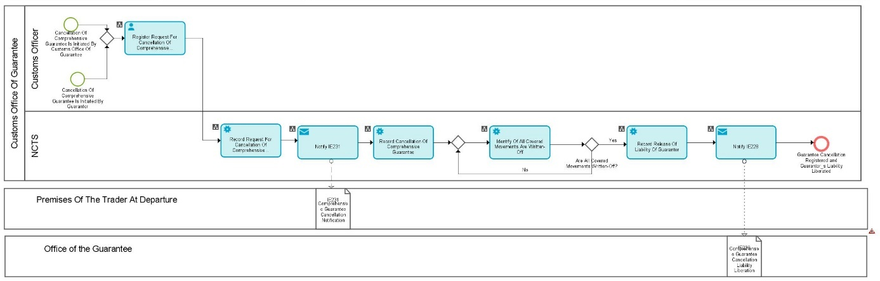

Figure 14: L4-TRA-03-05-Cancel (And Revoke) Comprehensive Guarantee
This process thread manages the guarantees of types coded 0 and 1
Major Events
Customs Office of Guarantee or Guarantor wants to cancel a comprehensive guarantee
Organisation : Guarantor, National Customs Administration
Location : Customs Office of Guarantee
This event may be initiated by following qualified parties:
- Guarantor;
- Customs Officer of the Customs Office of Guarantee on his own initiative or upon request of the competent authority when they revoke the authorisation to use comprehensive guarantee or guarantee waiver.

All covered movements in ‘written-off’
Organisation : National Customs Administration
Location : Customs Office of Guarantee
All covered movements have been ‘written-off’.
Processes
Cancel (And Revoke) Comprehensive Guarantee | Process: L4-TRA-03-05
Capture and register guarantee cancellation
Organisation : National Customs Administration
Location : Customs Office of Guarantee
Constraint :
Description:
The Customs Officer of the Customs Office of Guarantee registers the cancellation of this comprehensive guarantee into NCTS with effect on the 16th day following respectively the request for cancellation or the notification of the revocation (Art 82.2 DA, Art 61 of Appendix I of the Convention).
The following actions are executed:
- informing the Guarantor about the cancelled comprehensive guarantee, e.g. by means of a standard letter;
- informing (IE231) the Trader (Holder of Transit procedure) about the cancelled comprehensive guarantee;
- waiting till all movements, covered by the cancelled comprehensive guarantee, reach the ‘written-off’ state.
When the cancellation of the comprehensive guarantee has taken effect, the corresponding guarantee document must be retained by the Customs Office of Guarantee at least until the writing-off of all the movements covered by the cancelled comprehensive guarantee. During this period, the Guarantor’s liability may still be activated.
Final situation :
The cancellation of the guarantee is recorded in NCTS.

Cancel (And Revoke) Comprehensive Guarantee | Process: L4-TRA-03-05
Inform Guarantor about his liberated liability
Organisation : National Customs Administration
Location : Customs Office of Guarantee
Constraint :
Description :
If no more movements are covered by the cancelled comprehensive guarantee (when all the movements are ‘written off’), the liability of the Guarantor (related to a cancelled comprehensive guarantee) is released and the Guarantor is informed (IE228).
Final situation :
The movements covered are checked out and the Guarantor’s liability is released.

Major Results
Guarantor informed about cancelled guarantee
Organisation : Guarantor
Location : Customs Office of Guarantee or premises of the Guarantor
The Guarantor is informed that the guarantee is no longer valid.

Holder of Transit procedure informed about cancelled guarantee
Organisation : Trader
Location : Trader At Departure
The Holder of Transit procedure is informed about the cancelled guarantee.

Guarantee cancellation registered
Organisation : National Customs Administration
Location : Customs Office of Guarantee
The cancellation of the guarantee is registered in the guarantee management subsystem.

Guarantor’s liability liberated
Organisation : Guarantor
Location : Premises of the Guarantor
The Guarantor’s liability related to a cancelled guarantee can no longer be activated.

L4-TRA-03-06-Process individual Guarantee in the form of vouchers
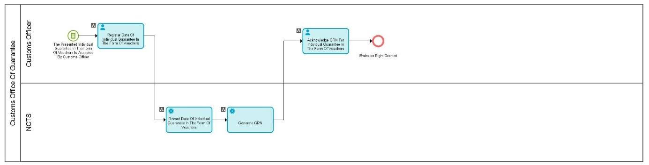

Figure 15: L4-TRA-03-06-Process Individual Guarantee in the form of Vouchers

Major Event
Guarantor asks for an individual guarantee in the form of vouchers emission right
Organisation : Guarantor
Location : Customs Office of Guarantee
A person or institution (e.g. bank, insurance, transport association) wants to get the right for the emission of NCTS individual guarantees in the form of vouchers. He presents the document “Individual guarantee in the form of vouchers“ (see Annex 32-06 IA and Annex B2 of Appendix III of the Convention), of which Part I has been filled in.
Process
Process individual guarantee in the form of vouchers data | Process L4-TRA-03-06
Organisation : National Customs Administration
Location : Customs Office of Guarantee
Constraint :
Description :
- If the Customs Officer at the Customs Office of Guarantee does not accept the presented guarantee he notifies the Guarantor.
- If the Customs Officer at the Customs Office of Guarantee accepts the presented guarantee:
- He completes Part II of the document “Individual guarantee in the form of vouchers”, validates it (stamp and signature), allocates an acceptance number (part II of the document) and files the related document. (If necessary, the Customs Officer at the Customs Office of Guarantee limits the number of vouchers to be issued, or, in NCTS, limits the number of vouchers ‘in circulation’ in case of doubt about financial capacity of the Guarantor).
- The data of the accepted individual guarantee in the form of vouchers is recorded in NCTS. NCTS builds the basic fields (1, 2, 3, and 4) of the GRN based on the allocated number (see under Heading 1.1.2.4 ’Guarantee Reference Number (GRN)’). That basic part will be used by the Guarantor later on for each NCTS individual guarantee voucher sold.
- The Customs Officer communicates the basic part of the GRN to the Guarantor.
Final situation :
The emission right for NCTS individual guarantee vouchers is accepted or not. When accepted, the individual guarantee data is recorded in NCTS and the basic part of the GRN is built. The acceptance is communicated to the Guarantor.

Remark: The process thread L4-TRA-02-07-Manage Guarantor is used to handle any information about the Guarantor.
Major Results
Emission right refused
Organisation : Guarantor
Location : Customs Office of Guarantee
The right for the emission of NCTS individual guarantee in the form of vouchers is refused.

Emission right granted
Organisation : Guarantor
Location : Customs Office of Guarantee
The Guarantor has the right to deliver NCTS individual guarantee vouchers.

Information about individual guarantee in the form of vouchers recorded
Organisation : National Customs Administration
Location : Customs Office of Guarantee
The information concerning the new individual guarantee in the form of vouchers is recorded in NCTS.
Minor Result
Individual guarantee in the form of vouchers document filed
Organisation : National Customs Administration
Location : Customs Office of Guarantee
The guarantee document “Individual guarantee in the form of vouchers” is filed at the Customs Office of Guarantee.

L4-TRA-03-07-Sell NCTS individual Guarantee Vouchers
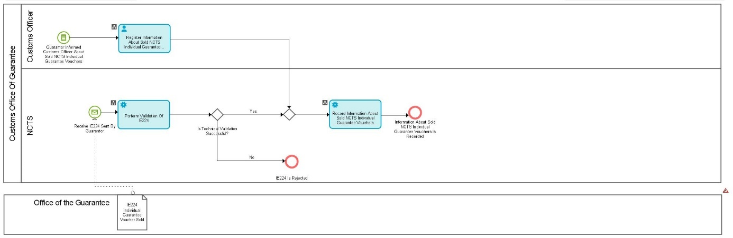

Figure 16: L4-TRA-03-07-Sell NCTS Individual Guarantee Vouchers

Major Event
Guarantor informs about sold NCTS individual guarantee vouchers
Organisation : Guarantor
Location : Premises of the Guarantor
A Holder of Transit procedure applies to a Guarantor to buy a certain number of NCTS individual guarantee vouchers to cover his Transit movement(s). The Guarantor (authorised for the emission of individual guarantee vouchers) fills (or probably prints) one or more “individual guarantee voucher” documents Annex 32-06IA and Annex B3 of Appendix III of the Convention) and sells the voucher(s). For each NCTS individual guarantee voucher, the Guarantor communicates to the Holder of Transit procedure the GRN that identifies the voucher in NCTS and the access code that allows its use. The Guarantor must inform (IE224) the Customs Office of Guarantee at which the concerned individual guarantee in the form of vouchers document is lodged about the sold individual guarantee voucher(s).
Process
Sell NCTS Individual Guarantee Vouchers | Process: L4-TRA-03-07
Record information about sold NCTS individual guarantee vouchers
Organisation : National Customs Administration
Location : Customs Office of Guarantee
Constraint : The Customs Officer at the Customs Office of Guarantee may have to capture the data.
Description:
The data about the sold individual guarantee voucher(s) is recorded in the guarantee management subsystem.
Final situation :
The information about sold NCTS individual guarantee vouchers is recorded in the guarantee management subsystem.
Major Result
Information about sold NCTS individual guarantee vouchers recorded
Organisation : National Customs Administration
Location : Customs Office of Guarantee
The information about the sold NCTS individual guarantee vouchers is recorded in the guarantee management subsystem.

L4-TRA-03-08-Cancel (and revoke) Individual Guarantee in the form of vouchers
*This process covers mutatis mutandis the cancellation (revocation) of individual guarantee by Guarantor

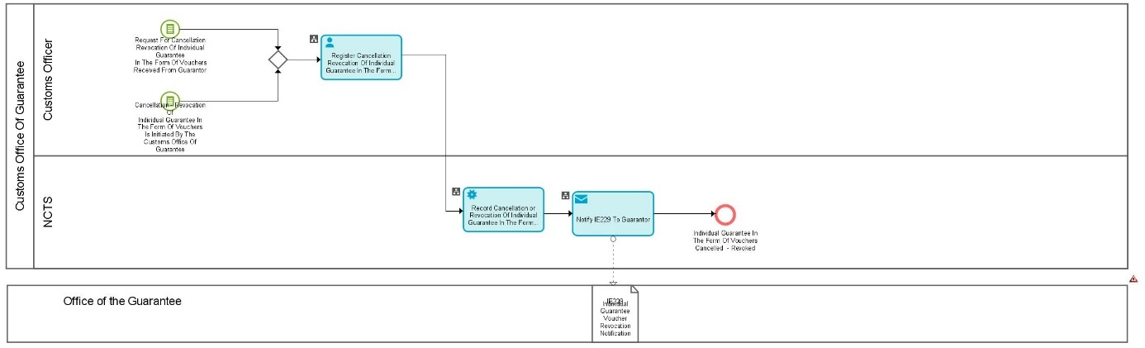
Figure 17: L4-TRA-03-08-Cancel (and revoke) Individual Guarantee in the Form of Vouchers

Major Event
Customs Office of Guarantee or a Guarantor want to cancel/revoke an individual guarantee in the form of vouchers
Organisation : National Customs Administration or Guarantor
Location : Customs Office of Guarantee
This event may be initiated by following qualified parties:
- Guarantor;
- Customs Officer at the Customs Office of Guarantee.
Process
Cancel/revoke individual guarantee in the form of vouchers | Process L4-TRA-03-08
Organisation : National Customs Administration
Location : Office of Guarantee
Constraint :
Description:
The Customs Officer at the Customs Office of Guarantee receives a request for cancellation of the Guarantor’s undertaking, or on its own initiative revokes the acceptance of the Guarantor’s undertaking.
The cancellation/revocation of the individual guarantee in the form of vouchers is recorded in NCTS with effect from the 16th day following respectively the request for cancellation or the notification of the revocation, meaning that all individual vouchers recorded in the system as sold, but not used, will become invalid as from that date (see Art 15 of Appendix I of the Convention and Article 161 IA).
The revocation is communicated (IE229) to the Guarantor.
Final situation :
The cancellation/revocation of the individual guarantee in the form of vouchers is recorded in NCTS.
Major Result
Individual Guarantee in the form of vouchers cancelled - Revoked
Organisation : National Customs Administration
Location : Customs Office of Guarantee
The information concerning the cancelled individual Guarantee in the form of vouchers is recorded in NCTS.

Certificates only exist for comprehensive guarantees and guarantee waivers.
only required if the national currency is applied.

